**FINAL TECHNICAL REPORT**

**ABSTRACT**

Opioid abuse with the resulting deaths has become a national health crisis in the United States. This project examined data from 1999 to 2016.The data points to an upward trend in the number of drug overdoses and deaths. These deaths accounted for over 70000 deaths last year. The correlation between Population, unemployment, Consumer Price Index, GDP Per-capita were analyzed. This project can help inform policy makers and stake holder on possible course of action.

**OBJECTIVES**

* This project analyzed and visualized data from the CDC in relation to drug deaths from 1999 to 2016.
* Analyze yearly reported deaths for correlation with several factors such as employment, labor force participation, GDP Per-capita, population, among others
* Examine trends in drug deaths over the years
* The States with the highest and lowest drug deaths will be examined
* Visualize drug deaths and the correlated factors
* I will use available data and analysis for forecasting

**FUNCTIONAL REQUIREMENTS**

* The platform must be able to store large amounts of data
* It should be possible to clean the data using this platform
* Platform must make it easy to reproduce the project
* It must be relatively easy to obtain licenses and authentication for the chosen system
* Visualization and reporting of final project must be possible in this platform

**SYSTEM ARCHITECTURE AND REQUIREMENTS**

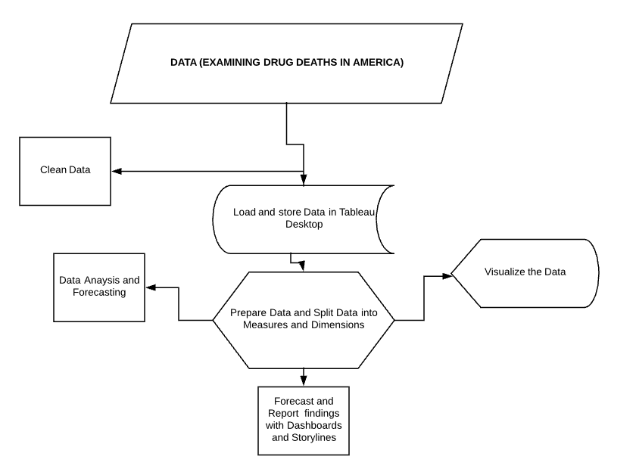

**DEVELOPMENT PLATFORM**

* Excel was used to clean and restructure the data for analysis and Visualization. Tableau will be used to create dashboards and storylines. The bulk of the project software was developed in Tableau

**PROPOSED VISUALIZATION**

. A line and bar graphs were used to capture the trend in drug deaths from 1999 to 2016.

. Maps were created of all the states in America with their corresponding drug deaths.

. The top two lowest and highest states experiencing drug deaths were visualized with maps

. A trendline was created to visualize the trend in deaths

. A boxplot was used to show the distribution of drug deaths

. A forecast indicator was also created to Visualize the Actual deaths verses the Estimated Value

**EXPERIMENTAL ANALYSES AND CONCLUSIONS**

. Drug deaths have been increasing since the data was tracked from 1999 to 2016

. There is a strong correlation between economic factors and drug deaths

. States with higher unemployment rate tended to see a higher rate of drug deaths

. West Virginia, Kentucky and New Hampshire were among the states with the Highest Drug deaths whiles states like California, Nebraska and Virginia has lower rate of drug deaths.

. The software forecasted an increase in drug deaths year over year

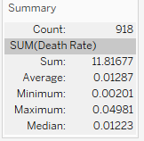

Fig1. Summary of the rate of drug deaths.

In conclusion, drug deaths will continue to trend upward year after year. Even though the data was only up to 2016, it predicted an increase for 2017 and 2018 which is consistent with the actual trend for last year and this year. Socio Economic factors continue to play a major role in in the rate of drug deaths. Wealthier states tended to have lower rates of drug deaths compared to poorer states. Understanding how each of these factors contribute to this problem is essential in other to tackle this crisis. Employment, education, population, GDP per-capita and the Consumer Price Index all had a positive correlation with drug deaths.